Spring boot provided official web site which help to create the project template.

https://start.spring.io/

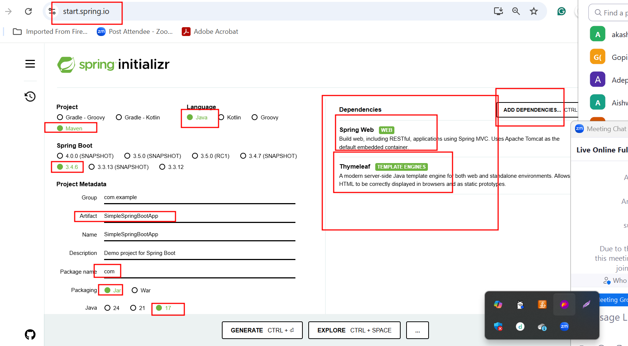

Creating spring boot project to do Product CRUD Operation using JdbcTemplate

Starter - Web starter for web application
Starter thymeleaf for view
Starter jdbc starter to do jdbc program using jdbcTemplate or datasource
Dependencies - mysql connector

